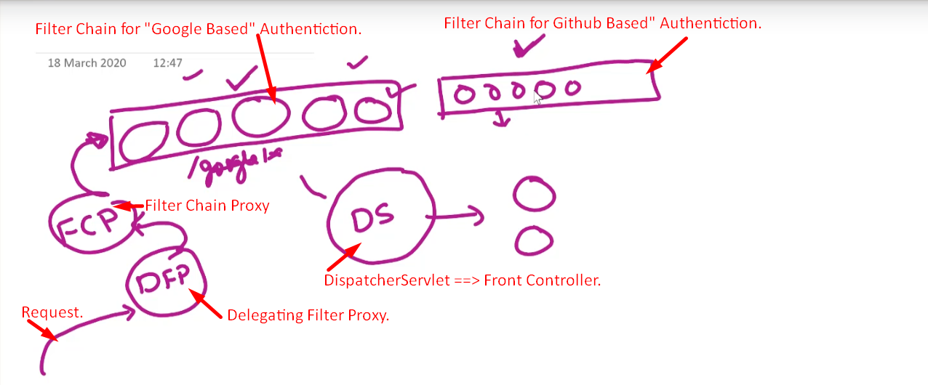

1. **DFP**: Delegating Filter Proxy.
   1. It will delegate request to FCP (Filter Chain Proxy)
2. **FC:** Filter Chain
   1. In your application, there may be many chains.
   2. Each chain is a set of filters.
   3. Why more than one Filter Chain?
      1. Maybe your application supports more than one type of authentication.
      2. Such as Google Authentication, Github Authentication etc.
      3. So, for each type of authentication, there is a separate filter chain.
3. **FCP**: Filter Chain Proxy.
   1. It will receive request from “**Delegating Filter Proxy**”.
   2. As it acts as “Proxy”, so it will pass the request to a particular Filter Chain based on type of authentication type that a user selects.  
      A user can select “Google Based” or “Github Based”.

Terminologies in Spring Security

1. **Principal:**
   1. An object which represents a logged in user/device/app.
   2. It is created when the user is successfully authenticated.
   3. It contains user details.
   4. One principal can multiple authorities (roles).
2. 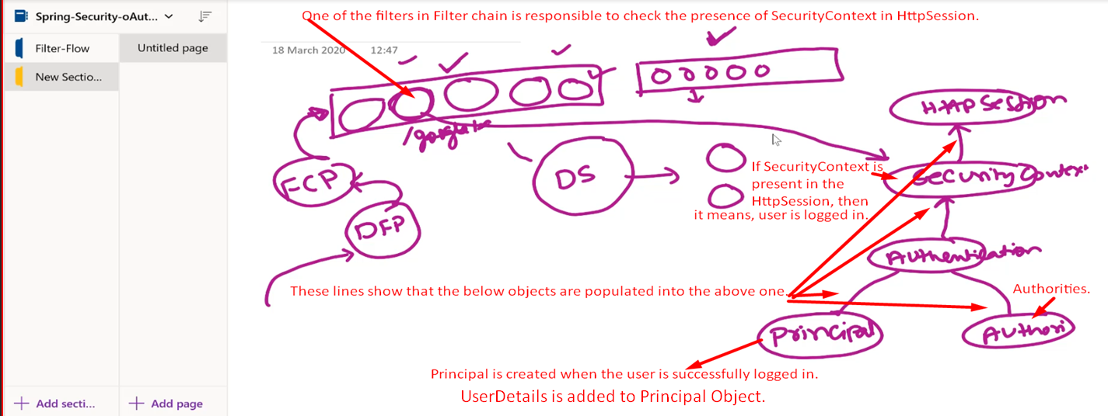
3. Let’s do some hands-on
4. 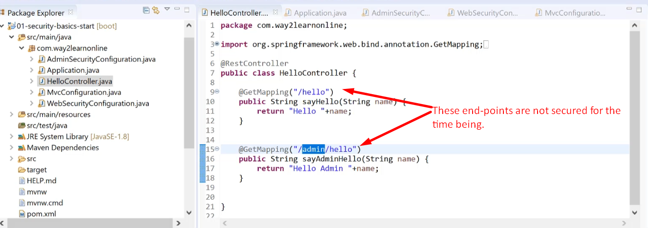
5. 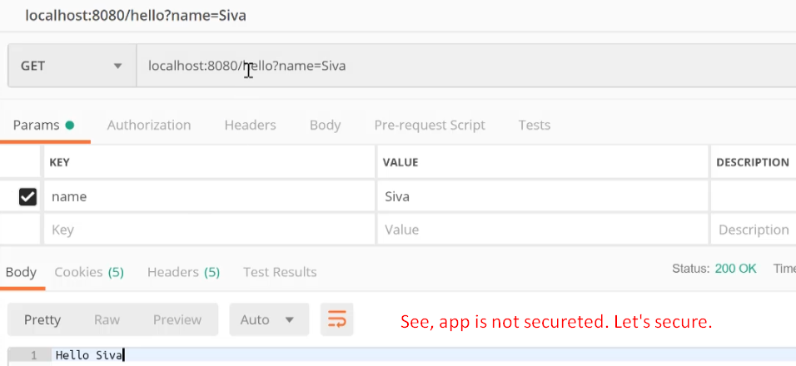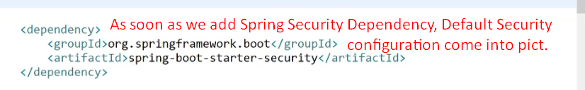
6. 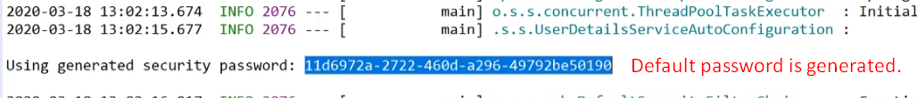By default a user with username “user” is created along with the above password.
7. 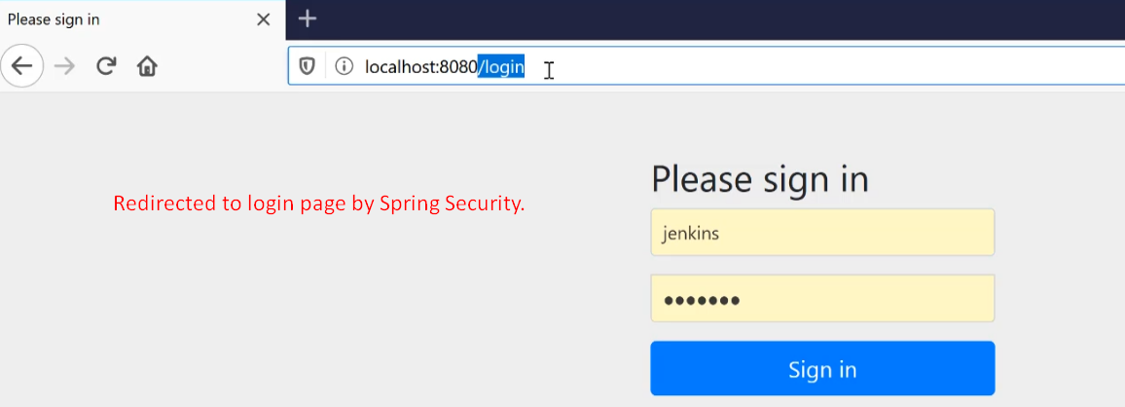
8. 